**Template Selector**

Overview 2

Main Screen 2

Created Games Screen 2

Selected Game Screen 2

New Game Screen 2

Existing Game Properties Screen 3

Specifics 3

Art Assets 4

Mockups 5

Main Screen – Layer 1 5

New Game/Created Games – Layer 2 6

Recently Opened Games – Layer 2 7

Creating a New Game – Layer 3 8

Selected Game – Layer 3 9

Properties of an Existing Game 10

Loading (clicked on an existing game or new game icon) – Layer 4 11

Loading (clicked on an existing game in the Recent Games) – Layer 4 12

Loading (clicked on a level to edit or the game icon) – Layer 4 13

Loading (clicked on Create on the new game properties) – Layer 4 14

Loading (clicked on Save in the Existing Games Properties) – Layer 4 15

# Overview

## Main Screen

* Each template will have its own icon on the main screen
  + 5 columns
  + 3 rows
  + Future Development:
    - When there are more than 10 templates for the editor, a page indicator will appear at the bottom, the user can click on the page circle to switch to it

OR

* + - The user can hover their mouse on either the left or right side of the template icons and a back and forth arrow will appear
* Last row will have links to the website and the most recent games the user has opened
  + 1st – Website (main page)
  + 2nd – Community/Forum
  + 3rd – Documents/Help
  + 4th – Marketplace/Store
  + 5th – Recent Games
  + Future Development:
    - These will stay constant and stationary, even if the page changes with the template icons

## Created Games Screen

* When a user clicks on a template icon the screen swipes to the right and shows the icons for
  + Back Arrow/Button
  + All Games the user has created with this template
  + An icon to create a New Game

## Selected Game Screen

* When a user clicks on a game icon, the screen swipes to the right and shows
  + The default icon for the template on the left
    - Clicking this icon launches the game
  + The list of levels on the right
    - If the user double clicks on the level or the arrow on the right of the level name, that scene loads for the user

## New Game Screen

* When a user clicks on a New Game icon, the screen swipes to the right and shows fields to edit
  + Icon for the MMGD Template Selector
    - Possible to use this icon in the future for when creating the executable/package and app
  + Title for the Game
    - Also changes the folder to this name
  + Number of Levels
    - Starts the user off with 1 level that has a generic title
    - User can add or remove levels
      * Creates/Removes scenes in the background
  + When they click on Create, the screen swipes to the right and shows the Selected Game screen (same screen as if they selected an existing game)
    - If the user clicks on the Back button from this point after a new game has been created, it will bring the user back to the Existing Games screen, not the New Game screen

## Existing Game Properties Screen

* When a user clicks on the Properties button, the screen swipes to the right and shows fields to edit
  + Icon for the MMGD Template Selector
  + Title for the Game
  + Clicking on Save will update the changed fields and bring the user back to the Selected Game Screen
  + Clicking on the Back button will cancel any changes made and bring the user back to the Selected Game Screen

# Specifics

* Icon Sizes
  + Main Screen
    - Template Icons – 200x200 pixels
    - Site Links and Recent Games Icon – 150x150
  + New Game and Existing Games Icons – 100x100
  + Recent Games – 100x100 pixels
* New/Update icon appears on the top right of an icon
  + Shown on all layers
  + If an update is available, the New Game Icon changes to help indicate there is an update
* When updating or creating a new game, the screen will dim and a loading indicator will be present
* When the user hovers over an icon with their mouse, the icon increases by 10%
* The new and recent games layers will contain
  + 10 columns of icons
  + 5 rows of icons
  + The first icon will always be a New Game from the template
  + No New Game icon in the Recent Game layer

# Art Assets

* New Icon/Indicator
* Back Arrow
* Previous Page Arrow
* Next Page Arrow
* 300x300 Icons
  + Tower Defense
  + Blackjack
  + Coming Soon
  + Website
  + Community
  + Documents
  + Marketplace
  + Recent Games
* 100x100 Icons
  + New Game
    - Plus Sign/New
    - Up Arrow/Update
  + Generic Tower Defense Icon
  + Generic Blackjack Icon
  + Marketplace Icon
* Loading Image
* Page Indicator
* Radios for Page Indicator
* Loading Image
* Scrollbar
* Levels to Edit container
* Tool list container
* Advancing arrow for level and tool container
* Greyed out screen overlay (for loading sequence)
* Generic Level Icon

# Mockups

## Main Screen – Layer 1

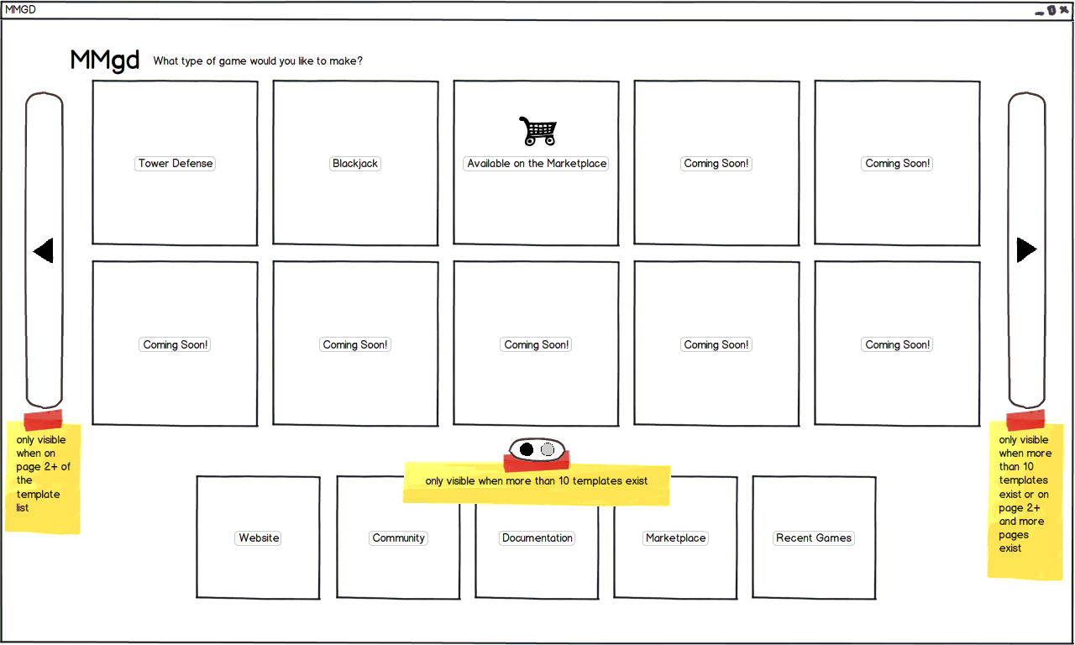

## New Game/Created Games – Layer 2

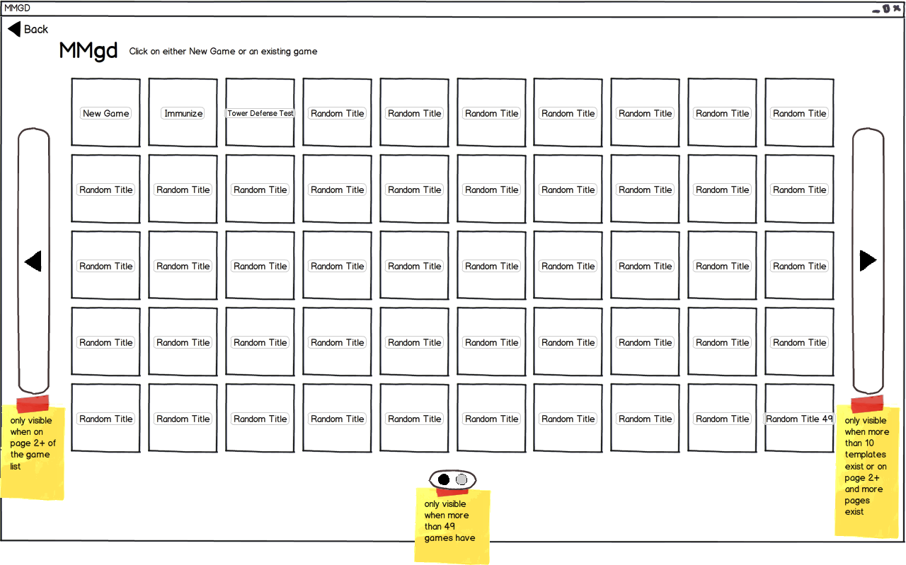

## Recently Opened Games – Layer 2

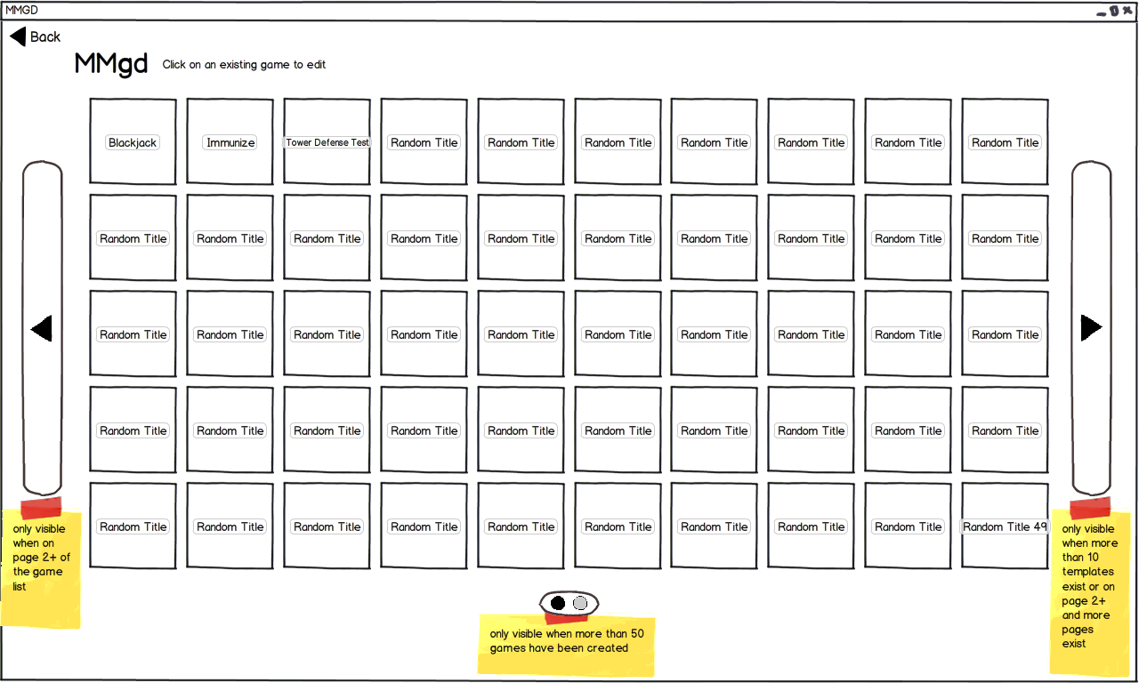

## Creating a New Game – Layer 3

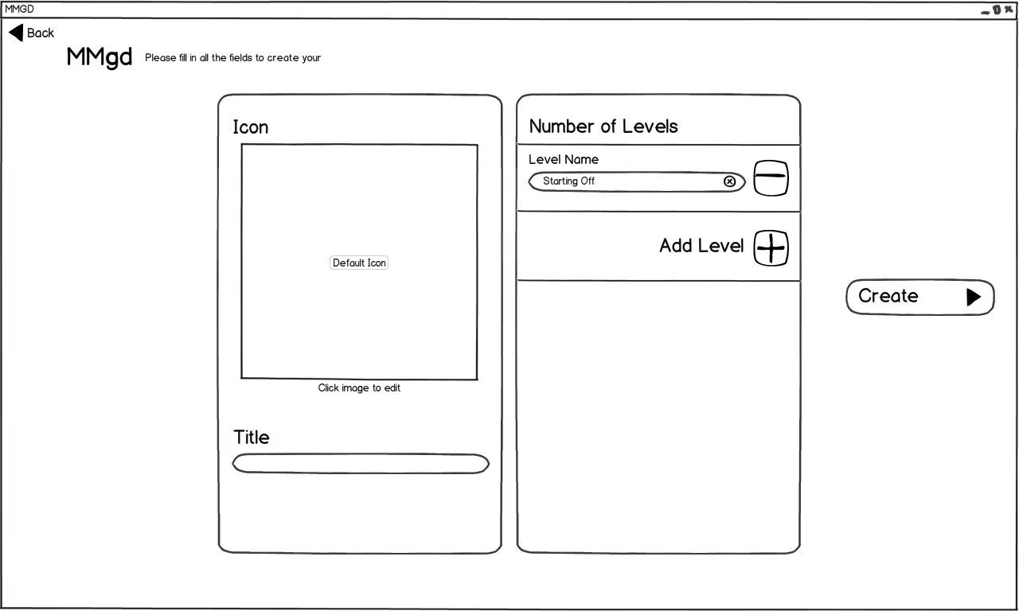

## Selected Game – Layer 3

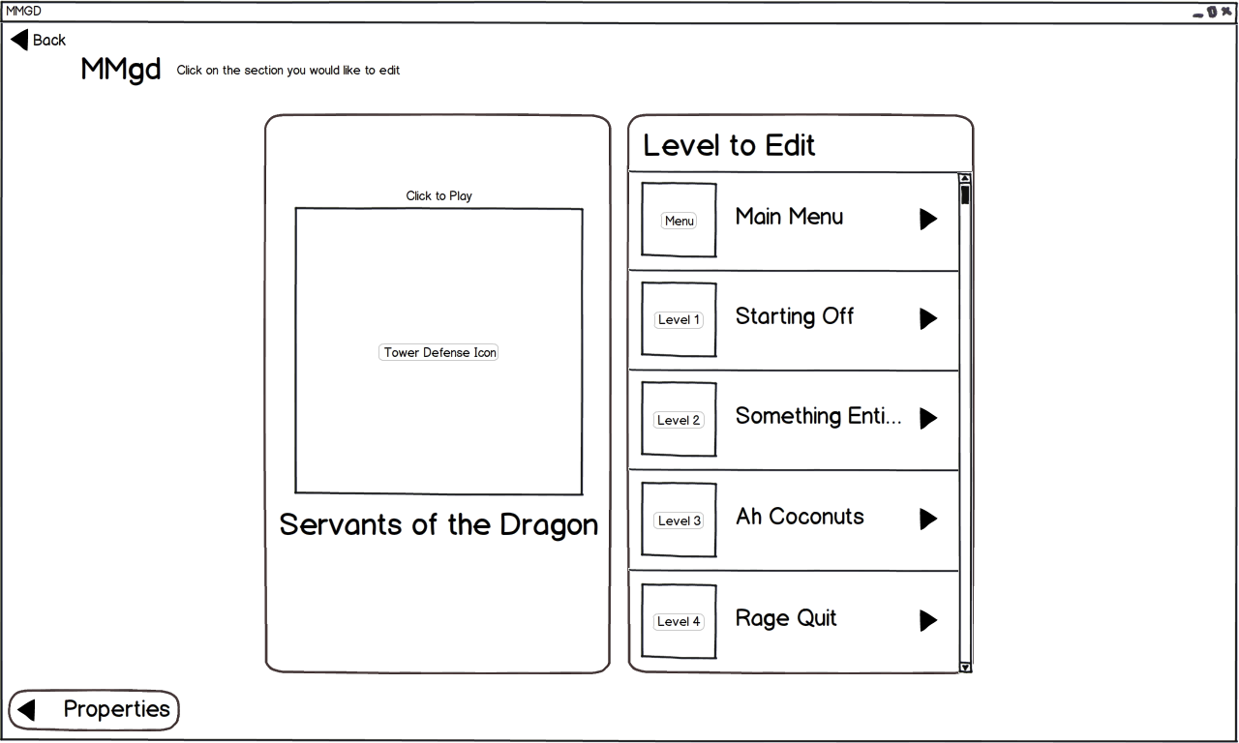

## Properties of an Existing Game

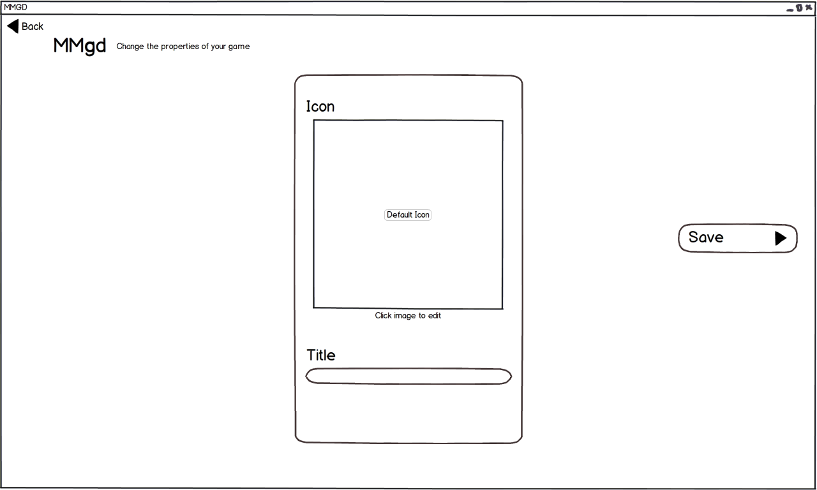

## Loading (clicked on an existing game or new game icon) – Layer 4

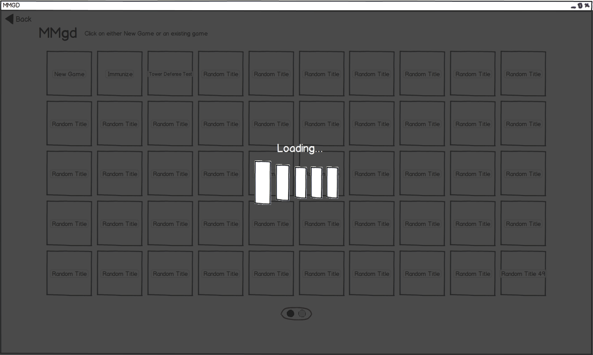

## Loading (clicked on an existing game in the Recent Games) – Layer 4

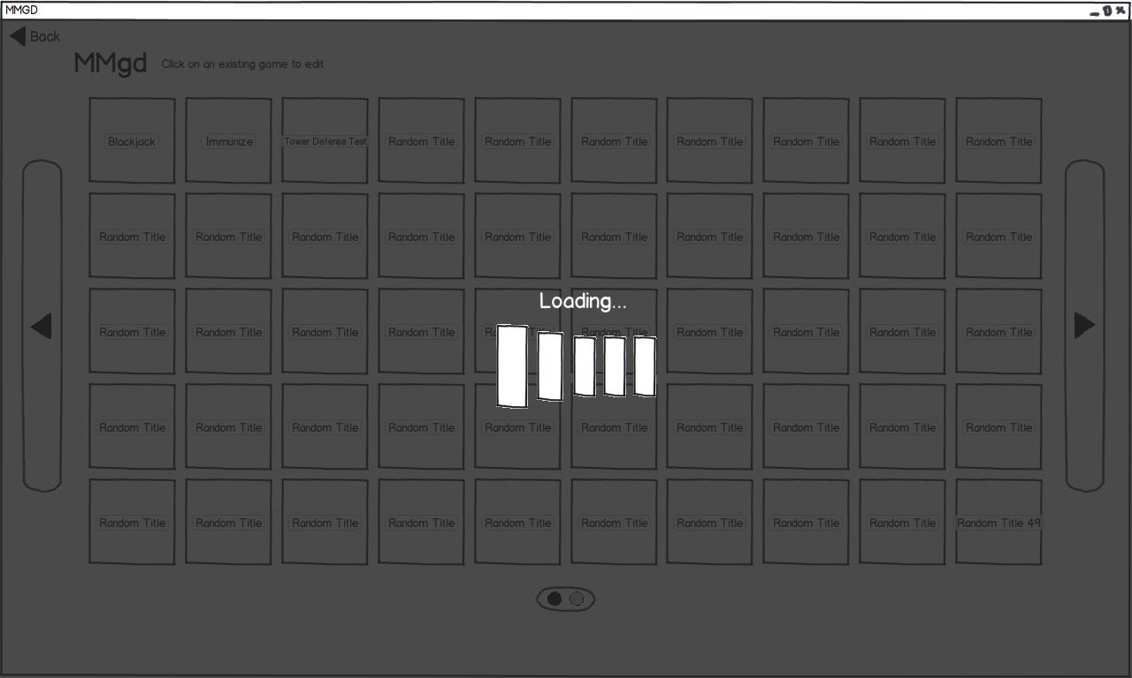

## Loading (clicked on a level to edit or the game icon) – Layer 4

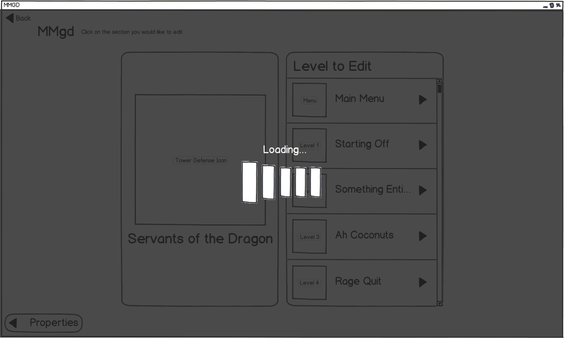

## Loading (clicked on Create on the new game properties) – Layer 4

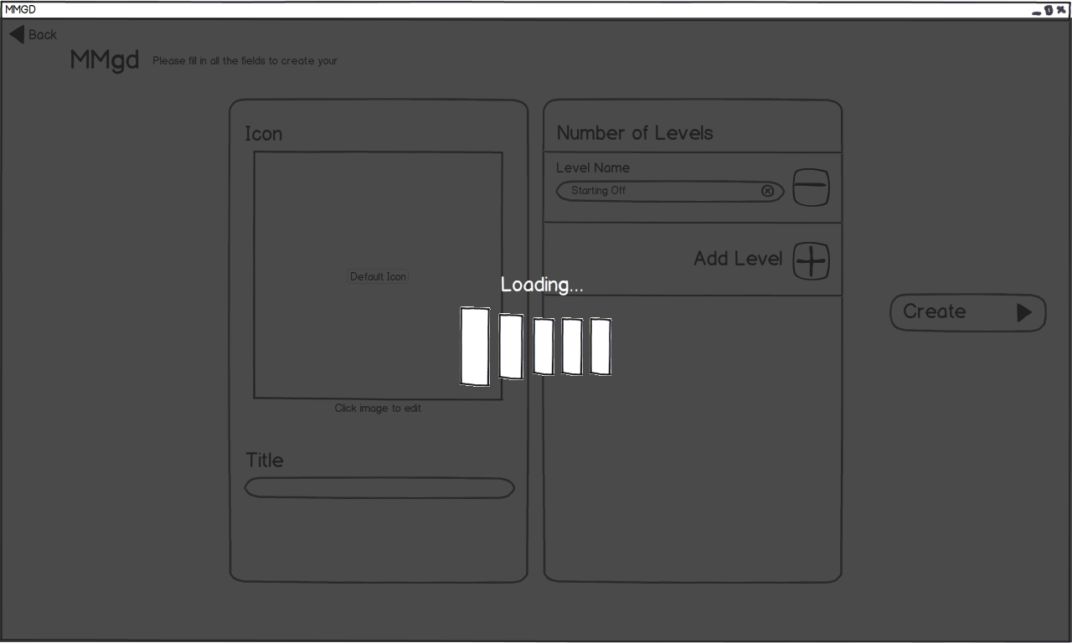

## Loading (clicked on Save in the Existing Games Properties) – Layer 4

